Act 48 of 1999 states that all certified educators must complete 180 hours of professional development every five years. All Act 48 continuing education should be designed to improve the effectiveness of teachers in meeting the specific needs of the students they serve. The 180-hour requirement can be met in any one of the following ways:
- Six (6) college credits
- Six (6) credits of professional education courses
- 180 hours of continuing professional education programs; activities or learning experiences; or any combination of collegiate studies, continuing professional education courses, or other programs, activities or learning experiences totaling 180 hours.
Act 24 of 2011 provided for a 2-year suspension (moratorium) of the Act 48 requirement for all certified PA educators. The Act 48 moratorium was lifted, effective June 30, 2013.
To see your current Act 48 status, go to www.pde.state.pa.us and choose Act 48 from the left margin.

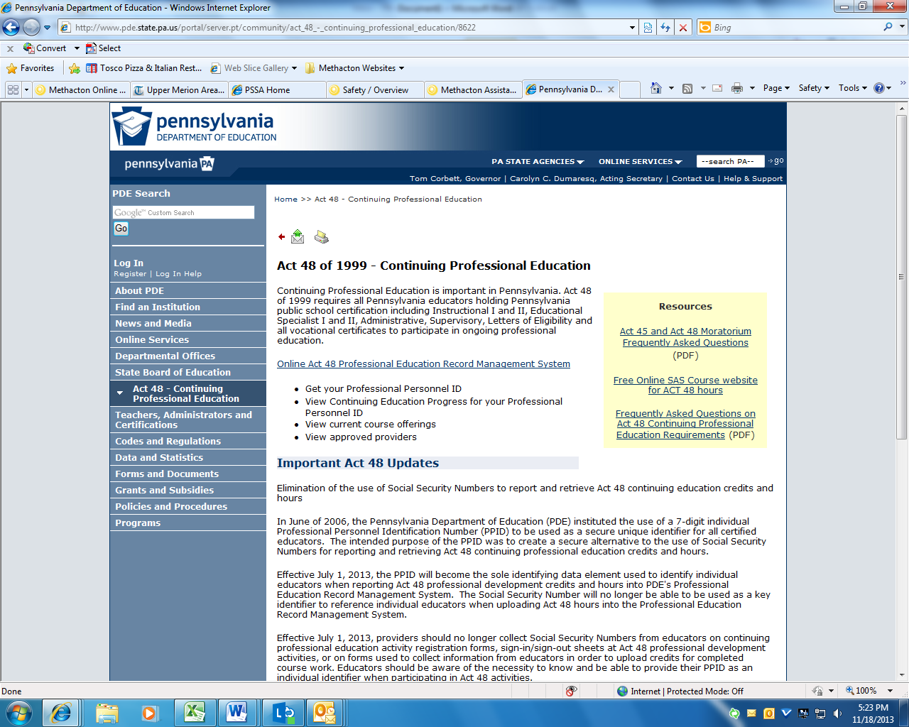
If you want to read more about the Act 48 moratorium, check out the FAQ link.
Click the online Act 48 Professional Education Record Management System

Enter your Professional Personnel ID (PPID) number in the box and hit ‘GO’ to review your Act 48 credits. If you don’t know your PPID, choose the ‘Get Your PPID” link.

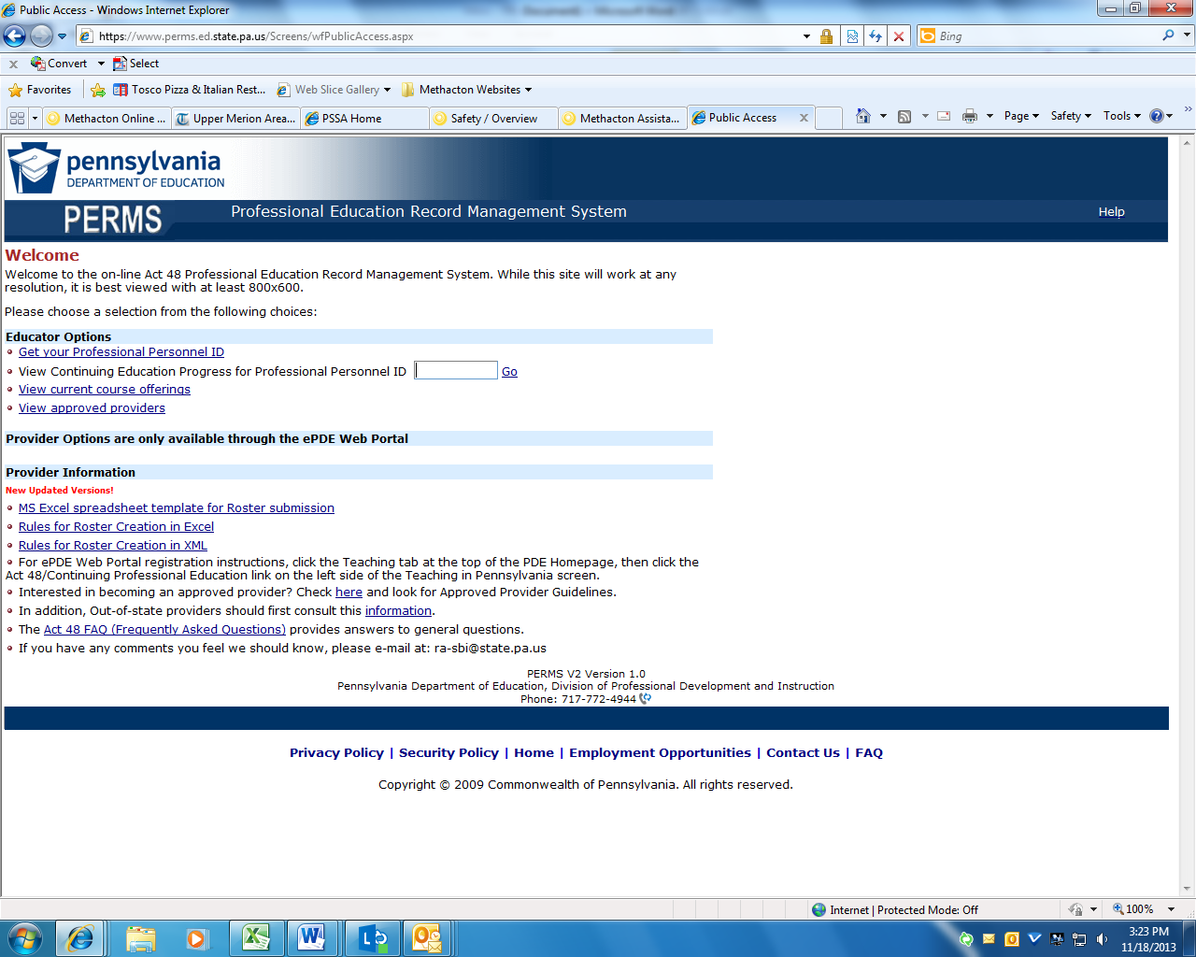
Your ‘Continuing Education Period’ should indicate 7 years instead of 5 years to accumulate the 180 hours for Act 48, because of the Act 48 moratorium enacted in 2011 and lifted effective June 30, 2013.
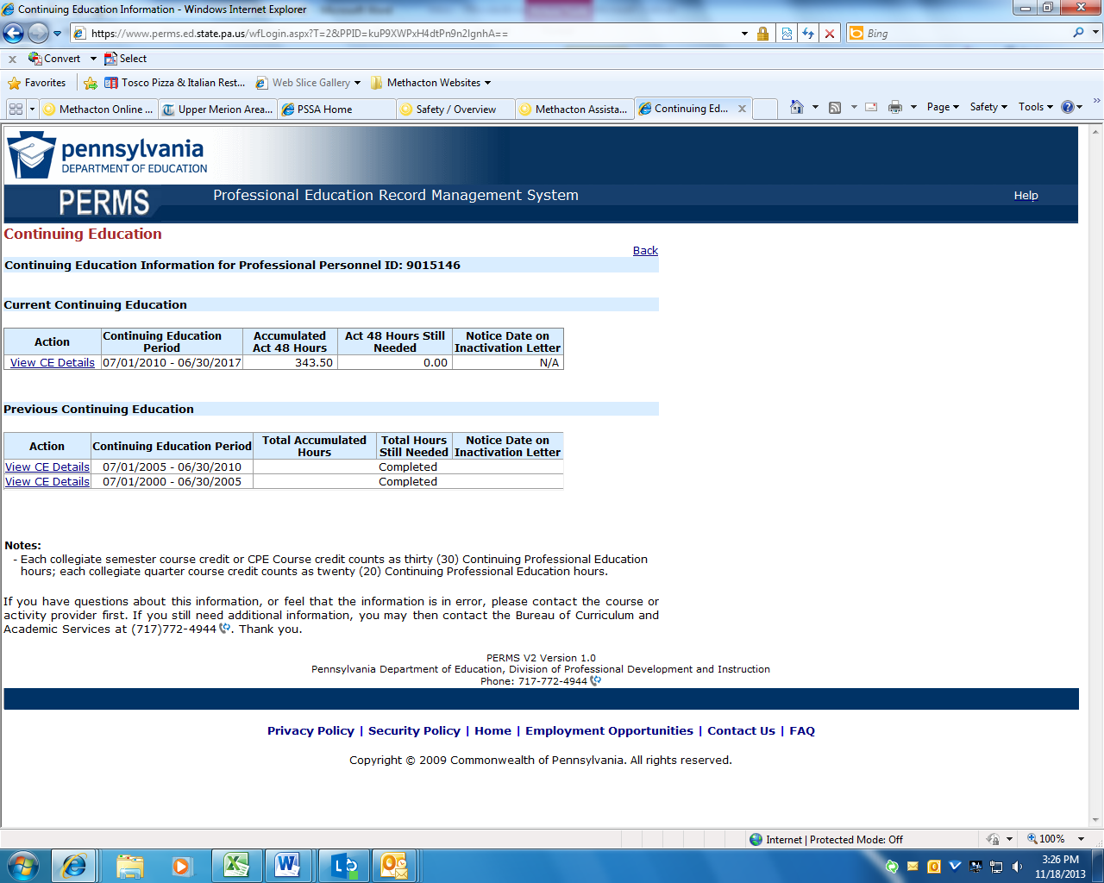
As long as your Accumulated Act 48 hours meet or exceed 180 hours by the continuing education period deadline, you’re in compliance and your certification is valid.

